Pre-Show Information
Passing Strange
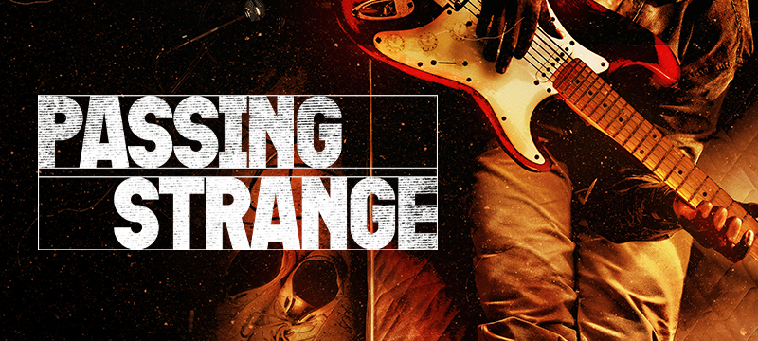
Book and lyrics by Stew
Music by Stew Stewart and Heidi Rodewald
Directed by Liesl Tommy
Introduction:
This document contains detailed information about the show in order to describe what you should expect when attending.
This includes information about the content warnings, plot, the space, lighting and sound, audience participation, and further access information.
All of the information in this document was correct at the time of publishing.
More information will be available closer to the time of performance.
Please note that by discussing the content of the show, the below information will contain key plot points and descriptions of what happens in the performance.
If you would like to receive elements of this information but avoid these spoilers, please do not read the section at the end of this document entitled ‘Show Synopsis’.
If you have any questions, please do not hesitate to contact our Box Office team:
E-mail: boxoffice@youngvic.org
Phone number: 020 7922 2922
Show Information:
Running Time: TBC
Content warnings:
- Themes of grief and bereavement
- Strong language, including sexually explicit language
- Discussions about and depiction of drug use
- Discussions about and depiction of sex work
- Depictions of violence
- Political unrest and rioting
- Mentions of slavery
- Passing mention of Nazism
Production warnings:
- Live music
Further production warnings will be confirmed closer to the show

The Auditorium
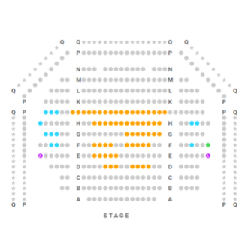

Passing Strange
This show will take place in our main auditorium, which is the larger of our three performance spaces.
For this performance, the space will be in an “end on” arrangement, meaning there will be seats on one side of the auditorium facing the stage.
Access to the main auditorium is via the upstairs (rows K - Q) and downstairs (rows A – J) via the main doors. Rows S & T are in the gallery. Our ushers are on hand to help you, they wear red t-shirts and jumpers with our logo.
Please arrive at the Young Vic with your ticket ready on your phone or have it printed before you enter or you can collect from box office.

Facilities:
There are toilets located on the ground and first floor at the Young Vic, via The Cut Bar. We have gender-neutral and accessible/baby changing toilets. Sanitary bins are available in all.
Building Accessibility:
All indoor venues will also be accessible with lifts & ramps and toilet provided.
Assistance Dogs:
Assistance dogs are always welcome at the Young Vic, if you are planning a visit please let us know in advance which performance you will be attending by calling our box office on 020 7922 2922 or e-mailing boxoffice@youngvic.org and we will be happy to look after your dog during the show.
Access for all:
For full information about our access measures, please visit our Access for all page, on our website here: www.youngvic.org/visit-us/access-for-all

Show Synopsis:
This will be available closer to the production

If you would like any further clarification or have any questions, please do get in touch with our Box Office team.
Email: boxoffice@youngvic.org
Phone number: 020 7922 2922
See you soon!
Welcome Team

