Pre-Show Information
Young Vic Taking Part presents

Tribe
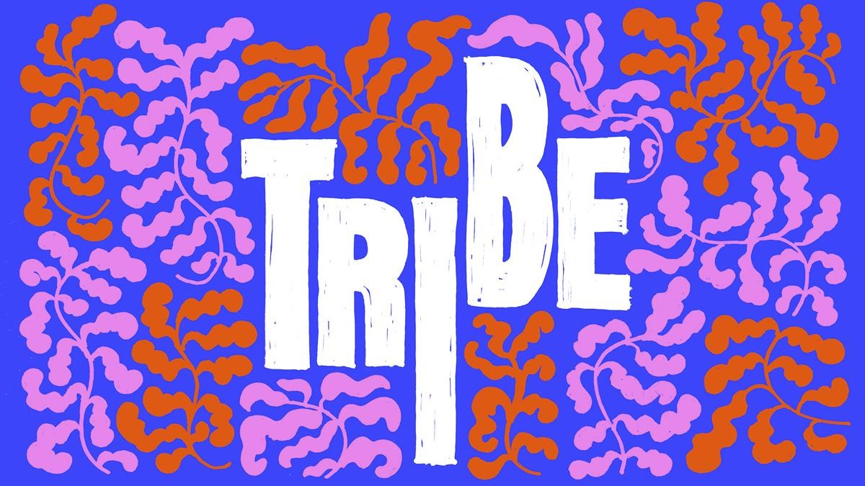
Written by Ronkẹ Adékọluẹ́jọ́ and The Company
Directed by TD Moyo

This document contains detailed information about the show in order to describe what you should expect when attending.
This includes information about the content warnings, plot, the space, lighting and sound, audience participation, and further access information.
All of the information in this document was correct at the time of publishing. More information will be available closer to the time of performance.
Please note that by discussing the content of the show, the below information will contain key plot points and descriptions of what happens in the performance.
If you would like to receive elements of this information but avoid these spoilers, please do not read the section at the end of this document entitled ‘Show Synopsis’.
If you have any questions, please do not hesitate to contact our Box Office team:
E-mail: boxoffice@youngvic.org
Phone number: 020 7922 2922

Show Information:
Running Time:
Approximately 1 hour 10 minutes with no interval
Content warnings:
Strong language and jokes involving threatening remarks
Production warnings:
Moments of audience interaction and loud music

The Auditorium
This show will take place in The Maria, which is the second largest of our three performance spaces.
For this performance, the space will be in an “end on” arrangement, meaning the seats will all face one way towards the stage. The maximum capacity is 90. Seating is unreserved.
Access to The Maria is via door 8 by outside The Cut Bar. Our ushers are on hand to help you, they wear red t-shirts and jumpers with our logo.
Please arrive at the Young Vic with your ticket ready on your phone or have it printed before you enter, or you can collect from box office.

Facilities:
There are toilets located on the ground and first floor at the Young Vic, via The Cut Bar. We have gender-neutral and accessible/baby changing toilets. Sanitary bins are available in all.
Building Accessibility:
All indoor venues are accessible with lifts & ramps.
Assistance Dogs:
Assistance dogs are always welcome at the Young Vic, if you are planning a visit please let us know in advance which performance you will be attending by calling our box office on 020 7922 2922 or e-mailing boxoffice@youngvic.org and we will be happy to look after your dog during the show.
Access for all:
For full information about our access measures, please visit our Access for all page, on our website here: www.youngvic.org/visit-us/access-for-all

Show Synopsis:
Tribe is a devised show that explores identity and sisterhood. The performance is as much for the company as it is for the audience. The women do not have character names but are rather, addressed by colours that manifest in some ways in their costumes.

After the audience enters, the women stand frozen after noticing them. This is repeated throughout the show whenever one of the women says the word “treehouse”, which acts as a moment for them to break character. There will be a treehouse with a swing in the centre of the audience bank that functions as a safe space for the women to go to whenever they want a break from being on stage.
The women begin to write rules for the space on the walls, encouraging some audience members to do this as well. Three actors discuss that they have frozen, but then agree they can take their time and leave the stage. The rest of the company explain to the audience that this is not a normal theatre show; that they are not simply there for the audience’s entertainment, but rather the stage is their space to tell their stories. They then perform a short movement sequence that leads into the first scene.

In this scene, Brown is upset and looking for her face, symbolising her sense of identity. Pink walks in, and Brown begs her for help, explaining the importance of her face and her belief that Blue has stolen it. Pink tries to reassure her, but Brown grows increasingly agitated, eventually calling “treehouse” to give them both a chance to cool off. Blue enters, and Brown angrily confronts her, asking if Blue stole her face. Calmly wafting incense about the room, Blue reminds Pink she is late for an appointment, and tells Brown that she shouldn’t be so dependent on her face, advising her to check her back pocket. Pink leaves for her beauty appointment, Blue follows her, and Brown, still angry, chases Blue. A stylised transition follows, taking us through to the salon where the next part of the play is set.

Yellow who runs the salon is telling Pink, Green and Black to queue up. Yellow explains her love for beauty treatments, referencing her self-made face cream before letting the other three inside. They settle in, and then Blue and Brown enter. Brown is wearing large sunglasses covering part of her face. Yellow reminds Blue she’s late for her customers, and it becomes clear that Green is in a hurry. Yellow tells Brown to remove her sunglasses which Brown does reluctantly due to her anxiety around her face having been stolen. However, the other women are uncommonly complimentary of Brown’s appearance despite this, which confuses and embarrasses her, ultimately causing her to call treehouse. The rest of the company help move her to the safe space before continuing with the scene. Yellow talks to Green about her nails, but repeatedly ignores Green when she talks about what she wants done and explains she is in a hurry.

Red enters, apologising for being late. Yellow chastises her, and Red explains she was on a date, but the man proved himself heartless in his inability to see beauty in the small things like art in a cup of coffee. Red hands Yellow a coffee, and Yellow begrudgingly forgives her and lets her get to work on Green’s manicure. Green and Red are clearly close, with Red being the first person to ask Green questions and listen to her responses. We learn that these characters grew up together, and Green like the other characters is hunting for something, or someone.

Pink suddenly calls “Treehouse” and goes to the safe space to talk to Brown, who has dropped character and admits to being a bit overwhelmed at “the acting thing”. Pink reminds Brown that she is doing this not for the audience but herself and her tribe, the other women in the company who are depending on her. She also suggests that Brown check her back pocket, but Brown refuses, and Pink returns to the main scene.

Pink enters the salon and is greeted warmly. She explains jokingly she has brought Primark underwear for all the women as gifts. Green asks Red why the other women refuse to listen to her, and they debate whether the women or their circumstances are to blame for their bitterness. Brown pipes in from the swing, asking the audience what they think. She explains that the company isn't perfect but have had strength to overcome challenges in their lives and insists on her own value, stating, “I am not simple mayonnaise. This here... is rare caviar. I am expensive!” Throughout this speech, she brings herself onto stage until at the end she rejoins the scene as Brown and the other women celebrate with her.

Brown offers to replace Red doing Green’s nails, but Red declines, with Green saying Red is the only one who listens to her. Yellow argues, but Green explains that responding doesn’t mean you’ve listened, mentioning that she used to have to explain this to her ex. This leads the women into a discussion about romantic relationships. Most of the women are jaded, but Black defends relationships, saying she loves her husband and explaining how his cooking made her fall in love with him. Throughout this conversation, we find out the person Green is looking for is her sister. Black says the women’s expectations of partners are too high, but Blue insists it’s important to have expectations, so you don’t tolerate bad treatment. Brown makes a joke about her getting passionate about the subject, and Blue harshly retaliates, saying Brown accepts bad treatment and calls her foolish. Brown lunges for Blue, and the women continue to argue until Yellow calls for quiet.

Yellow gives a speech where she insists that love has to start from within rather than being sought from a man. While she gives this speech, she is mixing her face lotion for Pink but not looking what she is putting inside. She applies it to Pink’s face and continues to talk about prioritising oneself rather than relationships. Pink’s face starts to burn from the cream, but Yellow ignores her concern. Pink calls “treehouse” and breaks character, and Green joins her in the safe space. Pink gives Green the room to finally talk about her lost sister, admitting she has lost her sister as well. The two take a moment for their shared sense of loss before rejoining the scene.

Upon rejoining the scene, Pink instantly reacts to her face, which is now burning, and Black rushes her offstage to put aloe vera on it. Blue and Brown start arguing again, and the characters run in and out trying to help and wondering what to do. Eventually, Pink re-enters, face covered. Her loss of her face allows her to sympathise with Brown who has been searching for her face all this time. Blue says Green can help as an emergency response nurse and starts to run offstage to get her, but Pink explains they have failed to help her find her sister and she is therefore under no obligation to help them. Pink apologises to Brown for not taking her seriously, and the women agree they need to help Green find her sister. Yellow feels disillusioned, insisting their mission is impossible, but Blue encourages her that trying is what matters, they follow the other women offstage.

The next part of the play is told through small handmade puppets. Green’s puppet appears, asking about her sister. A hill appears and she attempts to climb it but cannot. The other women’s puppets appear one by one, starting with Red, and build a tower to help her climb up to the top. When she reaches it, the puppet vanishes and the actor playing Green re-appears on stage. She explains that she finally feels heard and recognised and promises to help them up if the characters that need to apologise to each other. Blue admits that she stole Brown’s face, explaining that she did it because Brown didn't need it as her face is perfect as it is it. She insists, “Everything you’ve ever wanted from outside is already inside.” Blue apologises, and Brown forgives her, stating she won’t buy any more faces. Green pulls Brown and Blue’s puppets up, and their actors appear onstage.

Yellow apologises to Pink, assuring her she is still beautiful with her scars, and Pink accepts her apology. All the characters are brought onstage and regard the view with delight. In the final moments of the play, all the characters acknowledge that the sisterhood, beauty and love they have been looking for is with them all along – all they have to do is reach into their own back pockets.

If you would like any further clarification or have any questions, please do get in touch with our Box Office team.
Email: boxoffice@youngvic.org
Phone number: 020 7922 2922

See you soon!
Welcome Team

