Pre-Show Information
Chasing Hares
Written by Sonali Bhattacharyya
Directed by Milli Bhatia

This document contains detailed information about the show in order to describe what you should expect when attending.
This includes information about the content warnings, plot, the space, lighting and sound, audience participation, and further access information.
All of the information in this document was correct at the time of publishing. More information will be available closer to the time of performance.
Please note that by discussing the content of the show, the below information will contain key plot points and descriptions of what happens in the performance.
If you would like to receive elements of this information but avoid these spoilers, please do not read the sections at the end of this document ‘Show Information’ and ‘Show Synopsis’.
If you have any questions, please do not hesitate to contact our Box Office team:
E-mail: boxoffice@youngvic.org
Phone number: 020 7922 2922

The Auditorium
Chasing Hares

This show will take place in our main auditorium, which is the larger of our three performance spaces.
For this performance, the space will be in a ‘end on’ arrangement, meaning the seats are arranged on three sides of the stage (see below). The maximum capacity is 420.
Access to the main auditorium is via the upstairs (rows K – Q) and downstairs (rows A – J) via the main doors. Our ushers are on hand to help you, they wear red t-shirts and jumpers with our logo.
Our ushers will direct you to your seat, so please have your seat number ready on your phone or on a physical ticket before you enter the auditorium, so that they can help you.
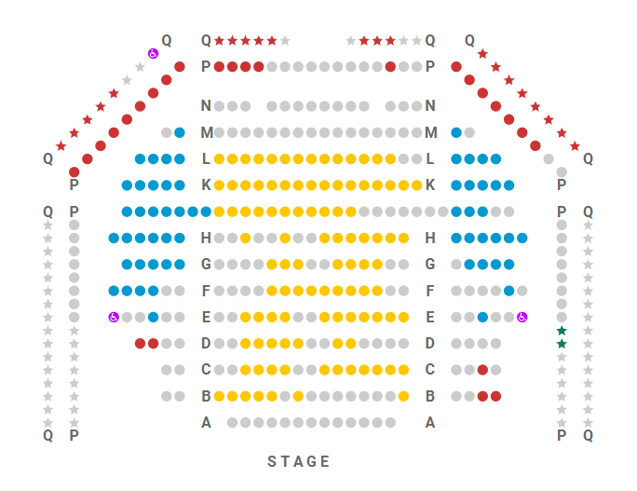

Facilities:
There are toilets located on the ground and first floor at the Young Vic, via The Cut Bar. We have gender-neutral and disabled/baby changing toilets. Sanitary bins are available in all.
Assistance Dogs:
Assistance dogs are always welcome at the Young Vic, if you are planning a visit please let us know in advance which performance you will be attending by calling our box office on 020 7922 2922 or e-mailing boxoffice@youngvic.org and we will be happy to look after your dog during the show.
Access for all:
For full information about or access measures, please visit our Access for all page, on our website here: www.youngvic.org/visit-us/access-for-all
Show Information:
Content Warnings:
Chasing Hares contains themes of grief and bereavement, death, and abuse and cruelty - specifically child labour exploitation. There are references to sexual misconduct, as well as to discrimination in contexts of race, class and social inequity. The production contains strong language, blood, cigarettes and there are scenes depicting violence, torture and the injured body of a minor. There is use of flashing lights, total blackouts, smoke, haze, loud music and sudden loud noise
Lighting:
- Bright lights
- Flashing lights
- Blinding lights
- Smoke
- Haze
- Total blackouts
- Projection and video
ACT 1 – 1 Hour 5 Mins
- Around 14 minutes in, there is a small amount of smoke and haze, which lingers on the stage for about 5 minutes. This is accompanied by loud noise for around 2 minutes.
- Around 17 minutes in, there are flashing lights for a few seconds, to simulate a thunderstorm.
- Around 51 minutes, there are blinding and flashing lights for around 10 seconds.
- There are more flashing lights around 63 minutes in which last for a few seconds, and are followed by a blackout that also lasts a few seconds.

INTERVAL – 15 Mins
ACT 2 – 45 Mins
- At the start of the act, there are blinding lights for a few seconds.
- Around 10 minutes in, a prop body of an injured minor is brought on, which will remain on stage for 2 minutes.
- Around 11 minutes in, there is a flash of blinding lights to simulate a camera flash.
- Around 13 minutes in, there is loud noise simulating a riot. This lasts for 2 minutes.
- Around 29 minutes in, there is a depiction of torture, which also features blood, which lasts for 5 minutes.
- There are more blinding lights around 42 minutes in which last for a few seconds, and are followed by a blackout that also lasts a few seconds.

Sound:
- Sudden loud noises including crying babies, factory machinery, industrial sewing machines, traffic and other city sounds, angry crowds/rioting
- Loud music

Stage:
- Baby dolls
- Lit herbal and nicotine cigarettes (30 seconds)
- Blood
- Depictions of significant injury on a prop child
- Onstage violence
- Very strong language
- Shouting
- Discussions of sexual harassment, paedophilia, child labour, torture
- Depiction of torture
- Depiction of rioting
Show Synopsis:

Chasing Hares is about a factory worker named Prab, who lives in Kolkata, West Bengal with his wife Kajol and baby daughter Amba in the early 2000’s. We later follow Amba’s journey as an adult, in London trying to unionise the delivery drivers as well as her father Prab’s life and politics, as he navigates working in a garment factory, juggling his anti-unionist boss and his radical writing for the classic Bengali theatre form of jatra. His drive to do the right thing moves him and ultimately the consequences of his actions pushes both him, his friend and his family into danger.

More information will be available closer to the time of performance.
If you would like any further clarification or have any questions, please do get in touch with our Box Office team.
Email: boxoffice@youngvic.org
Phone number: 020 7922 2922

See you soon!
Welcome Team

