**Pre-Show Information**   
  
***An Oak Tree***

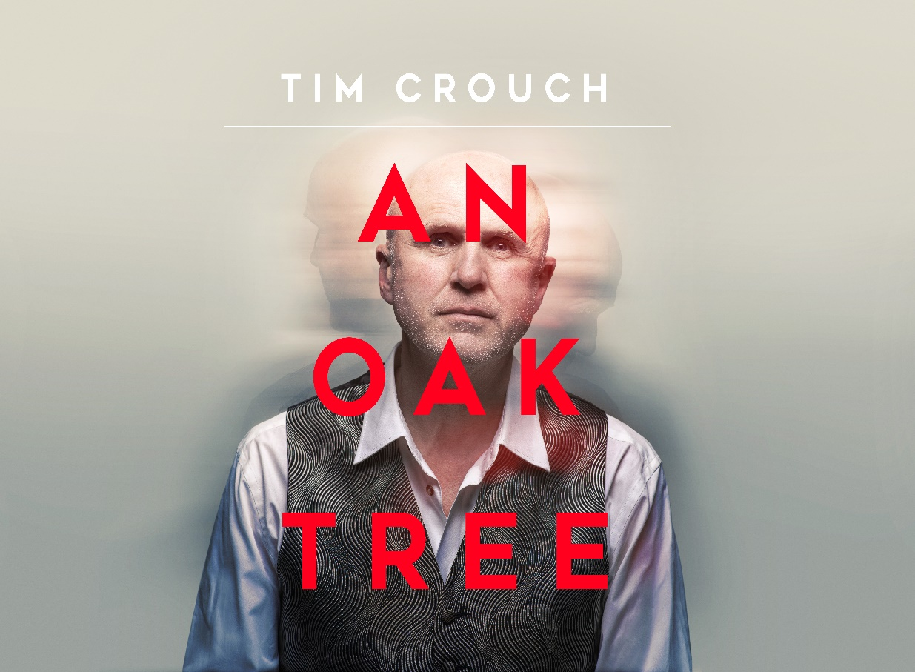

Written and Directed by Tim Crouch

**Contents**

**Page 2:** Introduction

**Page 3:** Show information, including running time and content warnings

**Pages 4- 5:** The auditorium, including access information

**Pages 6-9:** Show summary

**Introduction:**

This document contains detailed information about the show in order to describe what you should expect when attending.

This includes information about the content warnings, plot, space, lighting and sound, audience participation, and further access information.

All of the information in this document was correct at the time of publishing.

More information will be available closer to the time of performance.

**Please note** that by discussing the content of the show, **the below information will contain key plot points and descriptions of what happens in the performance.**

**If you would like to receive elements of this information but avoid these spoilers, please do not read the section at the end of this document entitled ‘Show Synopsis’.**

**If you have any questions, please do not hesitate to contact our Box Office team:**

**E-mail:** [**boxoffice@youngvic.org**](mailto:%20boxoffice@youngvic.org)

**Phone number: 020 7922 2922**

**Show Information:**

**Running Time:** 1 hour and 15 minutes

**Content warnings:**

* Death of a family member / child
* Grief
* Strong language
* Discussions of suicide

**The Auditorium**

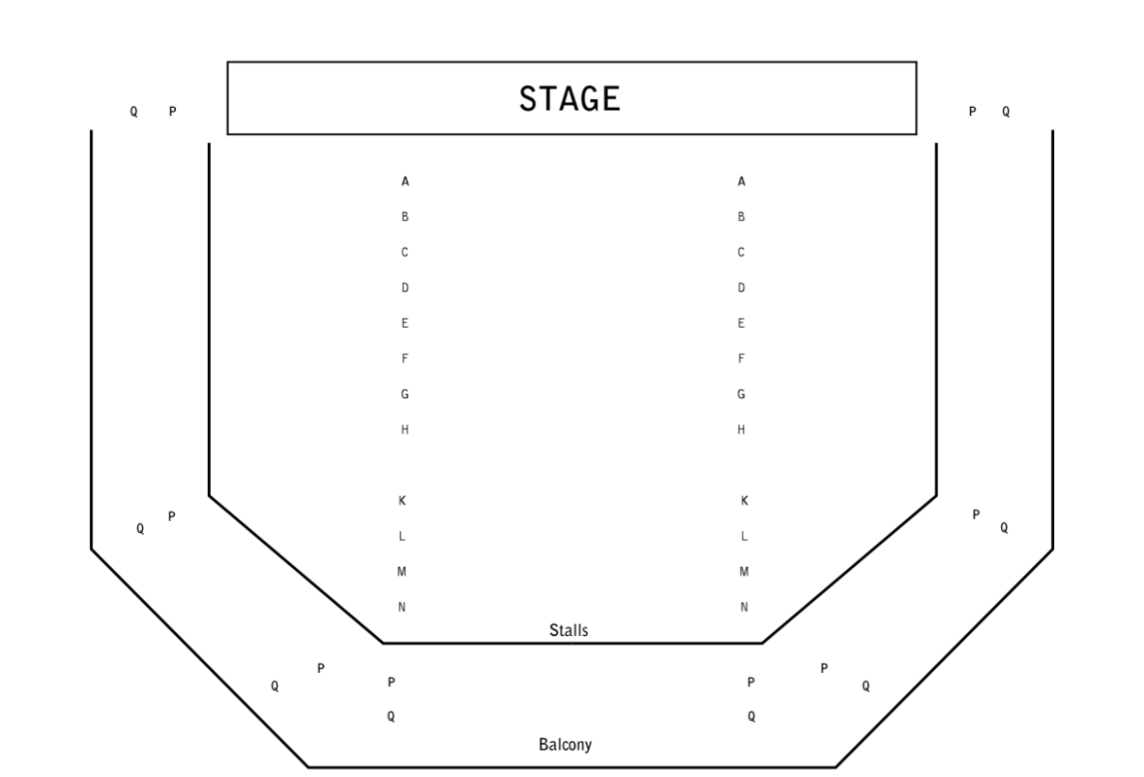

***An Oak Tree***

This show will take place in our main auditorium, which is the larger of our three performance spaces.

For this performance, the space will be in an “end on” arrangement, meaning there will be seats on one side of the auditorium facing the stage.

Access to the main auditorium is via the upstairs doors (rows K - Q) and downstairs (rows A – J) via the main doors. Rows S & T are in the gallery also accessible via the upstairs doors. Our ushers are on hand to help you, they wear red t-shirts and jumpers with our logo.

Please arrive at the Young Vic with your ticket ready on your phone. You could also print your ticket in advance of your visit, or you can collect your ticket from our Box Office.

**Facilities:**

There are toilets located on the ground and first floor at the Young Vic, via The Cut Bar. We have gender-neutral and accessible/baby changing toilets. Sanitary bins are available in all.

**Building Accessibility:**

All indoor venues are accessible with lifts & ramps and toilets provided.

**Assistance Dogs:**

Assistance dogs are always welcome at the Young Vic, if you are planning a visit, please let us know in advance which performance you will be attending by calling our Box Office on **020 7922 2922** or e-mailing [boxoffice@youngvic.org](mailto:%20boxoffice@youngvic.org) and we will be happy to look after your dog during the show.

**Access for all:**

For full information about our access measures, please visit our Access For All page, on our website here: [www.youngvic.org/visit-us/access-for-all](http://www.youngvic.org/visit-us/access-for-all)

**Show Synopsis:**

This will be available soon

If you would like any further clarification or have any questions, please do get in touch with our Box Office team.   
  
Email: [**boxoffice@youngvic.org**](mailto:%20boxoffice@youngvic.org)  
Phone number: **020 7922 2922**   
  
See you soon!   
  
**Welcome Team**