Pre-Show Information
Passing Strange
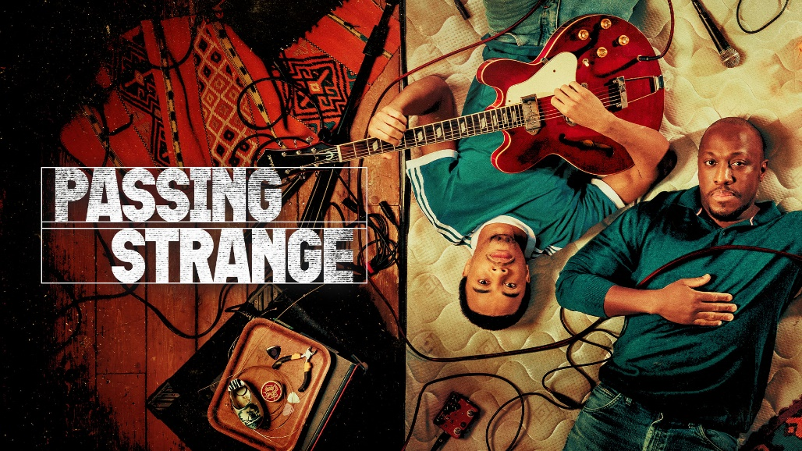
Book and Lyrics by Stew
Music by Stew Stewart and Heidi Rodewald
Directed by Liesl Tommy
Page 2: Introduction
Page 3: Show information, including show warnings
Page 4-5: Show warnings with timings
Pages 6-7: The Auditorium including access information
Pages 8-13: Show synopsis with sensory warnings

Introduction:
This document contains detailed information about the show in order to describe what you should expect when attending.
This includes information about the content warnings, plot, the space, lighting and sound, audience participation, and further access information.
All of the information in this document was correct at the time of publishing.
More information will be available closer to the time of performance.
Please note that by discussing the content of the show, the below information will contain key plot points and descriptions of what happens in the performance.
If you would like to receive elements of this information but avoid these spoilers, please do not read the section at the end of this document entitled ‘Show Synopsis’.
If you have any questions, please do not hesitate to contact our Box Office team:
E-mail: boxoffice@youngvic.org
Phone number: 020 7922 2922

Show Information:
Running Time: 2 hours 35 minutes including a 20 minute interval.
Content warnings:
- Themes of grief and bereavement including death of a parent
- Strong language including racial slurs and sexually explicit language
- Discussions about and depiction of drug use
- Discussions about and depiction of sex work
- Depictions of violence
- Political unrest and rioting
- Mentions of slavery
- Passing mention of Nazism
Production warnings:
- Loud music throughout
- Flashing lights throughout
- Haze throughout
- Strobe lights at the beginning of Act 2
- Actors in the audience part way through Act 1 and at the beginning of Act 2, and moments where actors climb over the audience to get to the back of the auditorium.

Please note these show warnings are subject to change until Tuesday 21 May, when the show will be finalised. For more information about when these moments occur in the show, please read the show synopsis starting page 6.

Show Warnings Timings:

Please note the timings below are all approximations.
There are references to slavery and loud music throughout the play, as well as mention of the loss of a parent.

Act I
First 2 minutes – Repeated sudden blackouts.
3 minutes – Flashing lights begin.
12 minutes – Flashing lights continue.
13 minutes – Flashing lights continue.
16 minutes – Fast flashing red lights begin.
17 minutes – Mother slaps Youth – flashing lights stop.
18 minutes - Flashing lights begin.
23 minutes - Depictions of drug use and hallucinatory states.
29 minutes – Reference to slavery.
34 minutes – Loud music.
37 minutes – Depictions of drug use and hallucinatory states, accompanied by bright lights on the screen at the back of the stage.
40 minutes – Terry enters the crowd and interacts with the audience.
41 minutes – Flashing lights as Sherry walks through the crowd.
49 minutes - Flashing red lights begin and very loud music.
1 hour 1 minute – Narrator runs into crowd and encourages audience participation.
1 hour 3 minutes – Song with sexual references, “WE JUST HAD SEX”.

Act II
Immediately – Alternating flashing lights and rapid moving black-and-white images on screen. Constant loud music. Actors in the audience.
2 minutes – Pulsing flashing lights.
4 minutes - Pulsing flashing lights and strobe lights.
6 minutes 50 seconds – Mr. Venus enters crowd while singing.
8 minutes - Depictions of drug use and hallucinatory states.
14 minutes – Reference to Nazism.
27 minutes – Cotton balls thrown into the crowd, hitting the first few rows.
30 minutes – Flashing lights.
35 minutes – Loud ringing.

The Auditorium
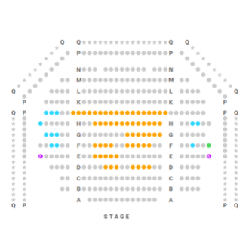

Passing Strange
This show will take place in our main auditorium, which is the larger of our three performance spaces.
For this performance, the space will be in an “end on” arrangement, meaning there will be seats on one side of the auditorium facing the stage.
Access to the main auditorium is via the upstairs (rows K - Q) and downstairs (rows A – J) via the main doors. Rows S & T are in the gallery. Our ushers are on hand to help you, they wear red t-shirts and jumpers with our logo.
Please arrive at the Young Vic with your ticket ready on your phone or have it printed before you enter or you can collect from box office.

Facilities:
There are toilets located on the ground and first floor at the Young Vic, via The Cut Bar. We have gender-neutral and accessible/baby changing toilets. Sanitary bins are available in all.
Building Accessibility:
All indoor venues will also be accessible with lifts & ramps and toilet provided.
Assistance Dogs:
Assistance dogs are always welcome at the Young Vic, if you are planning a visit please let us know in advance which performance you will be attending by calling our box office on 020 7922 2922 or e-mailing boxoffice@youngvic.org and we will be happy to look after your dog during the show.
Access for all:
For full information about our access measures, please visit our Access for all page, on our website here: www.youngvic.org/visit-us/access-for-all

Show Synopsis:
Please note this synopsis is subject to change until Tuesday 21 May, when the show will be finalised.

Blue – Flashing lights / haze
Green – Loud sounds / stage effects
Orange – smells
Purple – Potentially distressing themes / content

Act I
The auditorium is quite hazy at the beginning of Act I. (“PROLOGUE (WE MIGHT PLAY ALL NIGHT”) Narrator (Giles Terera) sings accompanied by the Band (Ikechukwu Onwuagbu, Nick Pinchbeck, James Taylor, Art Terry) as the cast enters. It’s Sunday morning and Mother (Rachel Adedeji) stands in a doorway as Youth (Keenan Munn-Francis), her son, lies sleeping. She encourages Youth to attend church with her while questioning his life choices and, particularly, fashion choices. Mother talks about the eternal life that Christianity promises its followers while positioning the Church as the saving grace of enslaved African Americans and their descendants.
(“BAPTIST FASHION SHOW”) Mother asks Youth for advice on her choice of outfit. Youth is somewhat dismissive and avoids directly responding, simply because he’d rather not be going to church.
(“CHURCH BLUES REVELATION”) Mother begins to pray for Youth while Narrator describes the change in the atmosphere during the church service. Suddenly, Youth exclaims “I’m having a religious experience!”.
(“MUSIC IS THE FREIGHT TRAIN IN WHICH GOD TRAVELS”) Mother and Youth argue as Reverend Jones (David Albury) ministers to the congregation. Mr. Franklin (Caleb Roberts) emerges, greeting Mother who praises him for his musical talents. Mother suggests that Youth should join the church choir, to which members of the congregation excitedly interject. Edwina (Nadia Violet Johnson) shares her desires for Youth’s future, which she sees herself being part of, including a need for him to “blacken up”. Terry (David Albury) enters, letting Youth know that Mr. Franklin has asked to see him.

Mr. Franklin, Youth and, Terry share a joint as Mr. Franklin comments that they’d be in a more comfortable setting if they were in Amsterdam. (“ARLINGTON HILL”) Narrator begins singing. Stoned, Mr. Franklin speaks about leaving America to attain a foreign lifestyle and level of success. Confused, Narrator comments that Youth hardly knew what Mr. Franklin meant when he spoke. Mr. Franklin ends up on the topic of slaves and Youth’s lack of belief in God. Mr. Franklin is taken aback by Youth’s change in demeanour once Youth realises that he and Mr. Franklin are pretending to be morally upstanding Black people in the similar way that Youth’s fair-skinned grandma would pass for white.
Terry, Sherry (Renée Lamb) and Youth are rehearsing and discussing their musical skills, or lack thereof, and whether they have a chance of succeeding in the music business. (“SOLE BROTHER”) Mother enters as Youth sings, letting Terry, Sherry and Youth know that there are sandwiches to eat when they’re hungry. Rehearsal ends and Mr. Franklin praises the band. Sherry lets Mr. Franklin know that being members of the church choir no longer interests her, Terry, and Youth as they’d prefer to create their own music. After this, Terry hands out tabs of LSD as they all look to each other hesitantly to see who will take the drug first. They eat their tabs and proceed to hallucinate, in which they fear growing old and living normal lives. The following section is accompanied by bright coloured lights on the screen at the back of the stage. Terry also enters the audience to speak to audience members directly.
(“MUST HAVE BEEN HIGH”) Terry, Sherry and Youth chat about touring and growing older. Terry enters the crowd and interacts with the audience as his high intensifies. (“MOM SONG”). (“PHILISTINES”) Philistines enter, making snide remarks about Youth. As the music stops, Youth shares that he’s saving money to move to Europe for good. Mother and Youth pretend that they’re in a black-and-white movie, sharing thoughts on joy and dreams. Mother leaves the conversation offended because Youth belittles her way of life.
(“MERCI BEAUCOUP, M. GODARD”) Youth takes a flight to Amsterdam. (“WELCOME TO AMSTERDAM”). Admiring his newfound surroundings, Youth ends up at a cafe where he meets Renata (Renée Lamb), a café waitress. They briefly speak about art, then in comes Christophe (David Albury), Joop (Caleb Roberts) and Marianna (Nadia Violet Johnson) who introduce themselves. As Narrator and Youth sing, they’re interrupted by Christophe who turns the conversation to jazz. Wrapping up Christophe’s interjection, Mariana shares that they’re all Youth’s new family. She sings “KEYS”, inviting Youth to stay at her place. Youth is grateful for her hospitality.
(“WE JUST HAD SEX”) Narrator, Marianna, Renata, and Youth sing about having sex and smoking cigarettes. Then, Youth speaks to himself, as if he were speaking to Mr. Franklin, about his feelings, latest sexual encounter, and time spent in Amsterdam thus far.
(“STONED”) Youth is writing a song as Marianna interrupts. He tells her that he finds songwriting easier when life is uncomfortable for him so he must move on from her. Mariana wishes Youth well in Berlin, letting him know that there is more to Amsterdam than he has seen. Youth responds that he’ll come back to Amsterdam if he doesn’t enjoy being in Berlin, but Mariana rejects this and ends the relationship. Narrator reflects on how Mariana’s act of kindness in offering her keys was a pivotal moment in his life.
[Stage Effects]
This act is accompanied by repetitive flashing lights and loud music throughout. Refer to Show Warnings Timings for approximations.

Act II
In Berlin, Youth is at the border. He struggles to understand the Border Guard (David Albury) who demands to verify his identity. A riot erupts and The Nowhaus Collective storms the stage (“MAY DAY”) This song is accompanied by strobe lights and haze, as well as very loud music. The Collective introduce themselves. There’s Hugo (David Albury), Sudabey (Nadia Violet Johnson) and Desi (Renée Lamb). (“SURFACE”) Mr. Venus (Caleb Roberts), a performance artist, performs as Narrator and Youth are enthralled. Mr. Venus enters the crowd while singing the line “What’s inside is just a lie”. The Nowhaus Collective repetitively chant, when Youth, in a fit of riot-fuelled adrenaline and testosterone, impulsively kisses Desi.
After the riot, Desi sits in a bathtub with Youth discussing current affairs and cultural norms. Youth attempts to relate to Desi’s revolutionary politics by insisting we must consider cultural specifics, and Desi dismantles his idea by reflecting that Nazism was culturally specific to 1930s Germany. (“DAMAGE”) Taking a political turn, Hugo, Mr. Venus, Spurney (Jerome van den Berghe), and Sudabey join the conversation, explaining that they aim to make their lives into art.
Youth begins to sing “IDENTITY”, a wild experimental song. In this song, Youth throws cotton balls at the audience. Youth is also reflected on multiple television screens on the screen at the back of the stage. Throughout this song Mother interjects, questioning why Youth doesn’t want to be around his “own people”, and Youth ignores her. Narrator joins in, leading to a big blues ending of the song.
Mr. Venus and Hugo interrupt, insisting that Youth’s time at Nowhaus is up as he is not a real revolutionary. In an effort to fit in and gain their respect, Youth begins to exaggerate the hardship he has experienced growing up in South Central L.A as a Black man. Narrator repeatedly interrupts to point out the inaccuracy of Youth’s statements, contrasting them with the reality of his sheltered privileged life in L.A through lines from Mother (“THE BLACK ONE”). Mr. Venus, Sudabey and Hugo are convinced, sympathising with Youth’s pain which must be a result of growing up in America.
Once the music stops, Desi questions Youth on why he pretends to be ghetto when he isn't. (“COME DOWN NOW”) As Mother sings, Desi continues speaking to Youth and then joins Mother in song. Mother rings Youth, which ends the song abruptly. She asks if Youth will be coming home for Christmas as his trip abroad has lasted for a long time. Youth reassures Mother that he has relocated for good and doesn’t plan on returning. When Mother questions why, Youth states that he can be himself abroad. Noticing Mother’s cold demeanour, Youth shares that he may be able to visit once he has finished his art commitments in the coming months.
The call ends and Youth shares with his friends that he’s finished his latest composition and plans to release it on Christmas Day. Sudabey comments that no-one will be around for Christmas and Hugo adds that they all go home for the holidays. Realising that he’ll be left alone, Youth questions why Desi isn't staying with him. Thinking that Mr. Venus will also be staying, Youth remarks that it’ll just be them spending Christmas together. Mr. Venus lets Youth know that he, too, is going home. To lessen the tension, Mr. Venus calls Hugo to look at his new miniskirt. Youth and Desi argue. Youth doesn’t understand why Desi goes back to her family who don't understand her life at all. She explains that despite this, they love her, unlike Youth who is in love with his art. She says she would be happy to show Youth how real love works, but Youth rejects this, insisting love isn’t real if someone has to change. Desi and the rest of the Nowhaus Collective leave.
Youth sings “YOUTH’S UNFINISHED SONG” as Narrator shares how Youth is spending the holidays. Narrator sings “WORK THE WOUND” and finishes by commenting on the journey from childhood to adulthood. We’re then at a funeral. Youth is alone on a podium and, as he gives a speech to honour Mother, it becomes clear it is her funeral. He laments, speaking of praying to have the chance to apologize to Mother. He begins to sing “PASSING PHASE” until the music stops immediately as Narrator interrupts and confronts Youth, continuing to sing the song himself. Mother appears, singing along with Narrator and reassuring him that “it’s alright” before she exits with Youth. Singing “LOVE LIKE THAT”, Narrator and Mother engage in a call and response as the play comes to an end.
[Stage Effects]
This act is accompanied by repetitive flashing lights and loud music throughout. Refer to Show Warnings Timings for approximations.

If you would like any further clarification or have any questions, please do get in touch with our Box Office team.
Email: boxoffice@youngvic.org
Phone number: 020 7922 2922
See you soon!
Welcome Team

