MANTELPEACE
An immersive exhibition from Taking Part
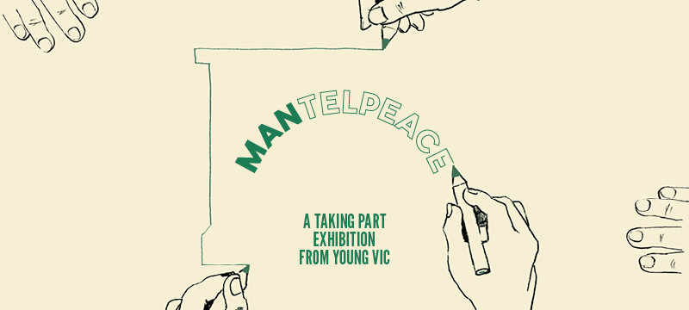

Introduction:
This document contains detailed information about the exhibition in order to describe what you should expect when attending.
This includes information about the content warnings, story, the space, lighting and sound, audience participation, and further access information.
All of the information in this document was correct at the time of publishing.
More information will be available closer to the time of performance.
Please note that by discussing the content of the show, the below information will contain key plot points and descriptions of what happens in the performance.
If you would like to receive elements of this information but avoid these spoilers, please do not read the section at the end of this document entitled 'exhibition Synopsis’.
If you have any questions, please do not hesitate to contact our Box Office team:
E-mail: boxoffice@youngvic.org
Phone number: 020 7922 2922

Exhibition Information:
The exhibition is divided into 1 hour time slots. You can arrive at any time during your time slot. You will then be free to move about the exhibition.
Content warnings:
- References to the criminal justice system
- Please note that some content will be generated by audience members due to the interactive nature of the exhibition
Production warnings:
- Moments with loud sounds/ music

This exhibition will take place in the Maria and Clare studios, which are our two smaller performance spaces, as well as the corridor between these spaces. There will be a suggested route around the exhibition, but you are free to take as long as you like to move through the spaces. The exhibition will be wheelchair accessible, and seats will be provided for those who require them. There will be a breakout space in the Marie-McKenna room, which is on the 1st floor of the building.
Access to the exhibition will be via the door at the back of the bar near the entrance to the toilets. Our ushers are on hand to help you, they wear red t-shirts and jumpers with our logo.
Please arrive at the Young Vic with your ticket ready on your phone or have it printed before you enter or you can collect from box office.
Facilities:
There are toilets located on the ground and first floor at the Young Vic, via The Cut Bar. We have gender-neutral and accessible/baby changing toilets. Sanitary bins are available in all.
Building Accessibility:
All indoor venues will also be accessible with lifts & ramps and toilet provided.
Assistance Dogs:
Assistance dogs are always welcome at the Young Vic, if you are planning a visit please let us know in advance which performance you will be attending by calling our box office on 020 7922 2922 or e-mailing boxoffice@youngvic.org and we will be happy to look after your dog during the show.
Access for all:
For full information about our access measures, please visit our Access for all page, on our website here: www.youngvic.org/visit-us/access-for-all

Exhibition synopsis:
Please find below a breakdown of what to expect from each section of the MANTELPEACE exhibition, including sensory warnings.
Green = Confined space
Blue = Music / sound

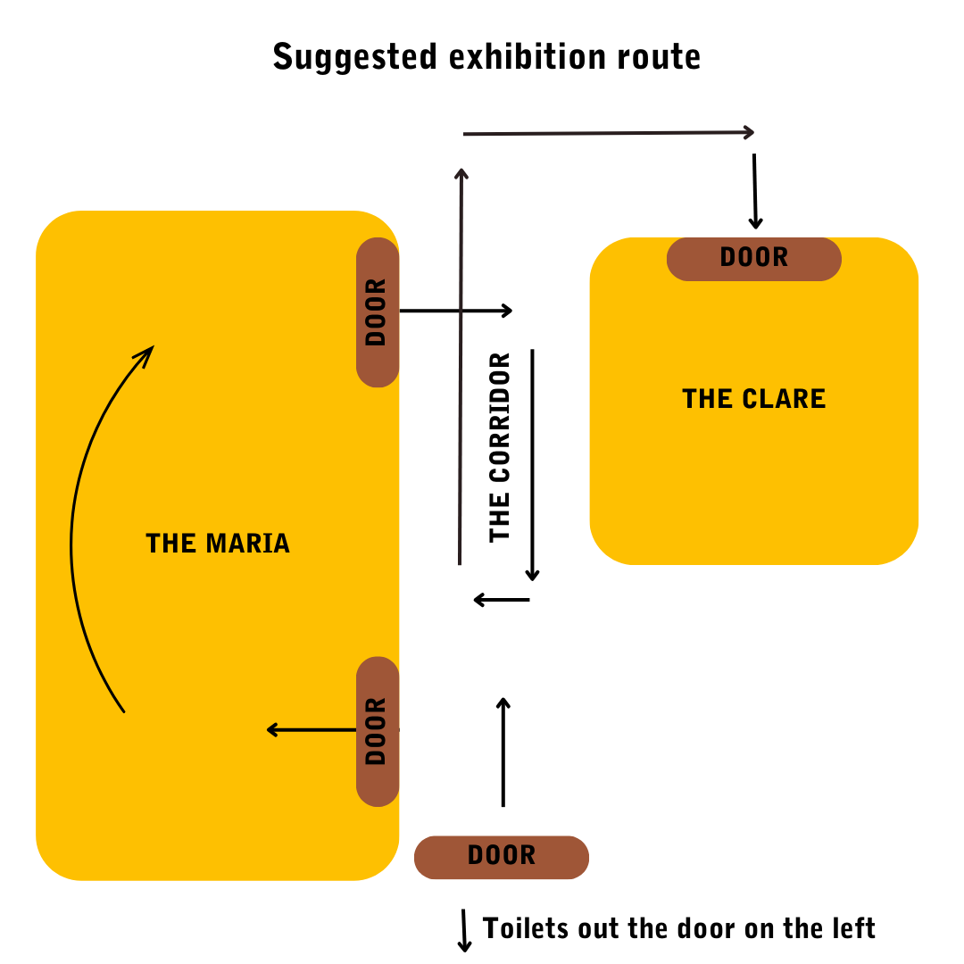

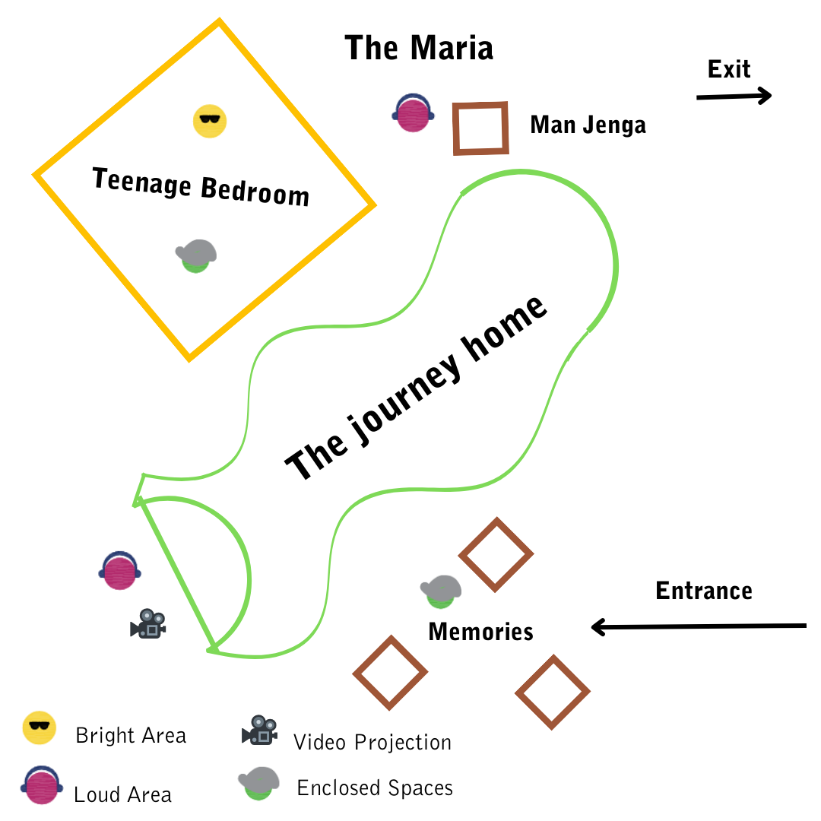
Memories section: Step inside a memory box to read the pieces of writing from one of our learning contributors. This portion of the exhibition will take place in a confined space which is optional to enter. The writing will also be printed on the outside of the memory boxes for those who don’t wish to enter. There will also be sound playing aloud in this area, which is the writing from inside the boxes being read out.
Journey Home section: A space that has been created to look like a park. Here, audiences will be invited to shoot footballs into a goal or sit on park benches and listen to audio recordings of park bench improvisations through headphones, as well as dialogue from our learning contributor sessions. You can also build a tower representing an ideal man with jenga blocks labeled with attributes made up by our learning contributors when exploring the theme of positive masculinity.
Teenage Bedroom section: A space that has been decorated to look like a bedroom, where a TV will display videos of a movement workshop from one of our learning contributors. Posters on the wall will display drawings from illustration workshops between a learning contributor and guest artists. You will also get to listen to two songs created by two of our learning contributors. There will be music playing aloud in this section of the exhibition.

Corridor
The corridor allows you to move from one studio to the other. The walls will display images of the process of making the exhibition.
There will be music playing aloud in this section of the exhibition.
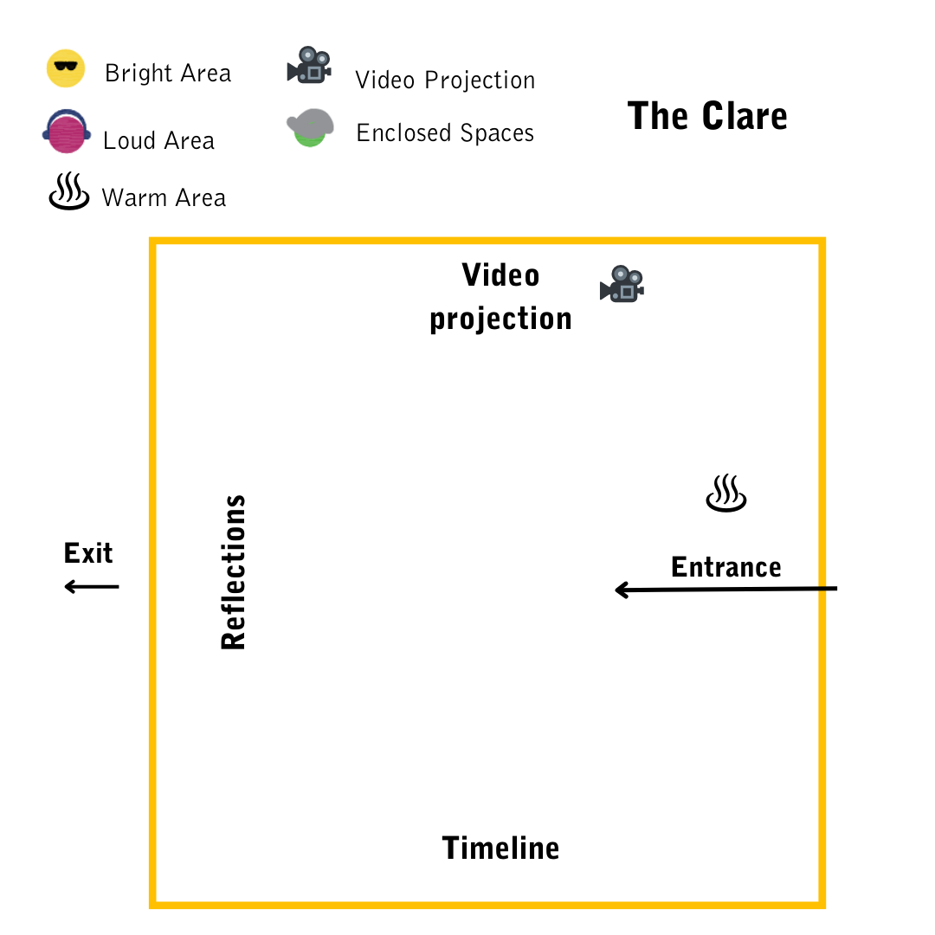
In this space, there will be a large projection on one wall of a video from our learning contributors.
The first section of this room will have a corkboard wall with a timeline running along it, where audience members will be invited to add defining moments that shaped their lives.
Finally, there will be a feedback wall where audience members are asked to respond to the exhibition from various prompts and use bulldog clips to attach these to the wall.
There will be music and sound playing aloud in this section of the exhibition.

If you would like any further clarification or have any questions, please do get in touch with our Box Office team.
Email: boxoffice@youngvic.org
Phone number: 020 7922 2922
See you soon!
Welcome Team

