Pre-Show Information
Punch
By James Graham
Based on the book Right From Wrong by Jacob Dunne
Page 2: Introduction
Page 3: Show information, including show warnings
Page 4: Sonic Story
Pages 5: The Auditorium, including access information
Pages 6-8: Show synopsis
Pages 9-12: Frequently asked questions and Resource list
Pages 13-14: Self-care guide

Introduction:
This document contains detailed information about the show in order to describe what you should expect when attending and support audiences experiencing the show.
This includes information about the content warnings, plot, the space, lighting and sound, audience participation, and further access information.
We have also collated information and resources in this document to help those who might find themselves affected by the contents or have concerns about their visit.
All of the information in this document was correct at the time of publishing.
More information will be available closer to the time of performance.
Please note that by discussing the content of the show, the below information will contain key plot points and descriptions of what happens in the performance.
If you would like to receive elements of this information but avoid these spoilers, please do not read the section at the end of this document entitled ‘Show Synopsis’.
If you have any questions, please do not hesitate to contact our Box Office team:
E-mail: boxoffice@youngvic.org
Phone number: 020 7922 2922

Show Information:
Running Time: approx. 2 hours 25 minutes including interval
Content warnings:
- Strong language
- References to violence, death, bereavement, alcohol and substance misuse, and mental health
- Knives on stage
- Based on real life people and events
Production warnings:
- Loud music throughout
- Flashing lights throughout
- Strobe lighting
- Sudden noises
- Theatrical smoke

Age Recommendation: 12 yrs+

Please note these show warnings are subject to change until Wednesday 5 March, when the show will be finalised.

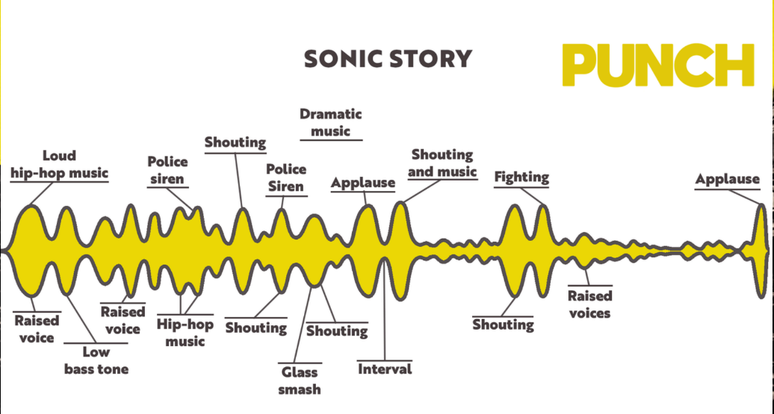

The Auditorium
Punch
This show will take place in our main auditorium, which is the larger of our three performance spaces.
For this performance, the space will be in an “end on” arrangement, meaning there will be seats on one side of the auditorium facing the stage.
Access to the main auditorium is via the upstairs (rows K - N) and downstairs (rows A – J) via the main doors. Rows P & Q are in the gallery. Our ushers are on hand to help you, they wear red t-shirts and jumpers with our logo.
Please arrive at the Young Vic with your ticket ready on your phone or have it printed before you enter or you can collect from box office.

Facilities:
There are toilets located on the ground and first floor at the Young Vic, via The Cut Bar. We have gender-neutral and accessible/baby changing toilets. Sanitary bins are available in all.
Building Accessibility:
All indoor venues will also be accessible with lifts & ramps and toilet provided.
Assistance Dogs:
Assistance dogs are always welcome at the Young Vic, if you are planning a visit please let us know in advance which performance you will be attending by calling our box office on 020 7922 2922 or e-mailing boxoffice@youngvic.org and we will be happy to look after your dog during the show.
Access for all:
For full information about our access measures, please visit our Access for all page, on our website here: www.youngvic.org/visit-us/access-for-all

Show Synopsis
We meet Jacob, an eighteen-year-old young man from the Meadows in Nottingham. He is talking to the audience about the day he killed a man called James. He is talking from the future about the past.
Jacob and his friend Raf are drunk and walking from the Meadows to town on a hot July day. They bump into people who are leaving a cricket match at Trent Bridge, and pick fights with them.
Jacob and his friends drink in lots of pubs in town, before becoming separated. Jacob meets a woman called Clare, who he flirts with, before Raf rings him to tell him to join in with their fight at Market Square.
Jacob runs to join the fight, and we see him getting ready to join in. The theatre goes black, and we meet young Jacob.
We meet Jacob’s mum and grandma. Jacob’s mum tells Jacob he is her little angel. His grandma tells him we all need a stake in the world to leave a mark.
As Jacob gets older, and he goes to secondary school, he befriends people in his year who encourage him to misbehave. He is diagnosed with ADHD, Dyslexia, and Autism.
Jacob begins to hang around with dangerous groups of people in the Meadows, taking drugs and getting involved in fights. He deals drugs and stops attending school as much.
Jacob talks about the different gangs in the area, and how they would get into fights. He talks about how some people would carry knives, but he didn’t.
Jacob’s Mum is upset with Jacob, as he keeps missing school. She tries to tell him to go back to school, but Jacob doesn’t listen.
We flash forward to just after Jacob attacks James. James is in hospital with a head injury. His parents, Joan and David, are very worried about him.
Meanwhile, Jacob has fled from the scene of the incident, back to the Meadows. He hopes to avoid what has happened and is upset when Raf calls him to let him know that James is badly hurt.
Jacob gets a call from his Mum, who says that the police are at their house. Jacob panics, and denies any wrongdoing, before throwing his phone into the River Trent.
Raf has told the police that it was Jacob who hit James, and Jacob goes to court where he hears that he has been sentenced to spend time in prison for killing James.
Joan and David watch Jacob go, and are upset at his prison sentence, as they do not think it is long enough. They are angry and confused about what has happened.
Jacob is moved into prison, where he is surrounded by other young offenders. They are all angry, and talking about getting back at the people who put them in prison when they get out.
Joan and David struggle with their grief. David appeals Jacob’s court sentence, wanting it to be longer. They feel like they have no support, and no answers to their questions.
In a search for answers, Joan and David meet with Restorative Justice, who hope that opening a conversation with Jacob will help them come to terms with what happened to James.
Jacob’s parole officer tells Jacob that Joan and David want to get in contact with him, and he is open to the idea but confused. He is struggling after leaving prison.
Jacob returns to his Mum’s house after leaving prison. She has lost her license to be a child minder due to Jacob’s crime, and is struggling with alcohol addiction. Jacob is upset to have negatively impacted her life.
Joan and David compose their letter to Jacob, asking him questions about why he attacked James, and if he had any martial arts training. They send Jacob the letter, and await a response.
Jacob writes back to them, and confirms that he didn’t know James. They begin a dialogue, and Jacob starts to rebuild his life through work and resitting his GCSEs.
After their conversation continues, Joan and David learn more about Jacob. They learn that his Mum has died. After two years, they decide to meet up in person, the final stage of Restorative Justice.
They offer to act as a reference for Jacob as he goes to University, stating that James would always have done the good thing in life. They are acting in James’ honour, and looking to make sure two lives aren’t wasted.
In the present day, Joan and Jacob talk about the benefits of Restorative Justice in the news. Jacob asks Joan and David for forgiveness, which they cannot give, but they continue to talk and work together to prevent further deaths like that of James.
The final scene sees Jacob as a grown man with a family, and speaking about the benefits of Restorative Justice. He is campaigning to ensure that young men like him don’t make the same choices he did.

Frequently Asked Questions:
Have the victims’ family been involved in the creation of this play?
Nottingham Playhouse would not have commissioned this play without the prior approval of James Hodgkinson’s family. We continue to respect the family’s wishes at all stages of the play’s production. We are committed to honour the stated wish of James’ parents – Joan and David – that two lives should not be wasted as a consequence of the manslaughter of their son. We seek to support them in raising awareness about the dangers of one punch and the benefits of Restorative Justice.
Will Nottingham Playhouse and Young Vic be making a profit from this play?
Nottingham Playhouse and Young Vic are charities and so any surplus made from our activities, including this production, will be directed back into our charitable purposes. This includes our engagement programmes – we have a long track record of success in delivering transformation projects and have seen the positive impact of engaging creatively with young people at risk of falling through the cracks in society.
Where can I find support if the themes of this play affected me?
We know that the subject matter of the play is challenging. To support audiences, we are providing:
- Links to online resources about the themes in the play, available on our website.
- A Show information and Self-care guide available on the Young Vic website and in emails sent to bookers in advance of seeing the show.
- You can contact the following support services for free if you would like to discuss any of the topics further:

Restorative Justice: If you’d like to find out more about the restorative justice process, you can find out more on the Remedi Remedi (remediuk.org) or Calm Mediation websites. The following organisations might also be useful to look at:
- Restorative Justice Council. The national, independent membership body for the field of restorative practice. https://restorativejustice.org.uk/

- Victim Support. Has information on victims’ rights to Restorative Justice. https://www.victimsupport.org.uk/help-and-support/your-rights/restorative-justice/
- Why Me. A national charity delivering and promoting access to Restorative Justice. https://why-me.org/

The dangers of one punch: One Punch UK is a charity raising awareness and educating people about the devastating impact one punch can have. https://onepunch.org.uk/. Additionally you might also want to look at this BBC Article containing studies of one punch deaths : https://www.bbc.co.uk/news/uk-38992393

Mental Health Support Organisations: Samaritans provides over the phone support for those considering suicide 24 hours a day, 365 days a year. Mind is a mental health charity, making sure no one has to face a mental health problem alone.
- https://www.samaritans.org/
- https://www.mind.org.uk/
You might also want to look at these organisations:
- The Compassionate Friends. Provides support to bereaved family parents and their families. www.tcf.org.uk

- Under the Bridge. Creates space and time for guys to come together. The focus is on getting out in blue spaces and doing things that help improve health and wellbeing. https://www.bluetonic.org.uk/under-the-bridge-choir
Criminal Justice Organisations:
- Appeal. A charity and law practice that fights miscarriages of justice and demands reform. https://appeal.org.uk/
- Catch 22. Works with young people and adults providing intervention, rehabilitation and victim services in prison and in the community. https://www.catch-22.org.uk/what-we-do/criminal-justice/
- Prison Advice & Care Trust (PACT). A pioneering national charity that supports prisoners, people with convictions and their families.
https://www.prisonadvice.org.uk/
- Prison Reform Trust. A charity working to create a just, humane and effective penal system. https://prisonreformtrust.org.uk/
- The Criminal Justice Alliance. A network of 200+ organisational and academic members working towards a fair and effective criminal justice system. https://www.criminaljusticealliance.org/
- The Longford Trust. A charity that supports people with convictions to reintegrate into society. https://www.longfordtrust.org/about-us
Young People Organisations:
- Barnardo’s. Offering support to make sure children and young people feel safer, happier, healthier and more hopeful, by running over 800 specialist services across the UK. https://www.barnardos.org.uk/

- Just for Kids Law. Helps children and young people in the UK to have their legal rights and entitlements respected and promoted, and their voices heard and valued. https://www.justforkidslaw.org/

- PACT’s Schools Toolkit. Information about supporting students affected by imprisonment. https://www.prisonadvice.org.uk/get-help/professionals/schools/

- Positively Empowered Kids CIC A non-profit organisation, specialising in early intervention and prevention of mental ill health in children and young people, through wellbeing events, workshops and programme such as resilience leaders & youth voice in action. https://positivelyempoweredkids.co.uk/

- Runaway Helpline (Gang Support). Provides support for anyone feeling like running away or are away from home due to gang involvement. https://www.runawayhelpline.org.uk/advice/gangs/

- Support Through Sport A CIC using a range of positive initiatives as diversion and intervention programmes to support young people whilst tackling negative influences such as knife crime, gang violence, youth offending and serious youth violence. https://supportthroughsport.co.uk/

- The Children’s Society. A national charity working to transform the hopes and happiness of young people facing abuse, exploitation and neglect. https://www.childrenssociety.org.uk/ .

- The Mix. Offers a range of support services for under 25s. https://www.themix.org.uk/

- YoungMinds A charity providing a range of support relating to young people’s mental health. https://www.youngminds.org.uk/

Self-Care Suggestions
Before The Show
Read the Summary or Synopsis
Preparing yourself by reading the summary, synopsis, or content warnings in this document may help you decide if you are comfortable with the content, and also help you gauge if there are any points you may not be comfortable with.
During The Show
Watch With Someone
Attending the show with someone who you trust, who knows you and your connection to the subject of the play, may help with the experience. They may be able to recognise when you need help or support and can assist you.
Step Away
It is important to know in yourself when it is time to step away, and there is nothing wrong with deciding that the show is not for you or is too much. The Front of House team are on hand if you want to leave.
Talk
We will be hosting post-show talks in the auditorium on 11 March and 19 March which will explore themes covered in the show.
Breathe
Breathing is a good way to help you feel calm. Try breathing in for four seconds, holding your breath for four seconds, then exhaling for four seconds. Repeat this as long as you need. This is called Box Breathing.
Ask For Help
If you found the content of Punch distressing, try talking to someone you trust or contacting one of the organisations listed above.

If you would like any further clarification or have any questions, please do get in touch with our Box Office team.
Email: boxoffice@youngvic.org
Phone number: 020 7922 2922
See you soon!
Welcome Team

