**Pre-Show Information**   
  
***The Little Foxes***



Written by **Lillian Hellman**  
Directed by **Lyndsey Turner**

**Introduction:**

This document contains detailed information about the show in order to describe what you should expect when attending.

This includes information about the content warnings, plot, space, lighting and sound, audience participation, and further access information.

All of the information in this document was correct at the time of publishing.

More information will be available closer to the time of performance.

**Please note** that by discussing the content of the show, **the below information will contain key plot points and descriptions of what happens in the performance.**

**If you would like to receive elements of this information but avoid these spoilers, please do not read the section at the end of this document entitled ‘Show Synopsis’.**

**If you have any questions, please do not hesitate to contact our Box Office team:**

**E-mail:** [**boxoffice@youngvic.org**](mailto:%20boxoffice@youngvic.org)

**Phone number: 020 7922 2922**

**Show Information:**

**Running Time:** 2 hours 15 minutes including a 20-minute interval. Please note that there is no re-entry to the auditorium.

**Content warnings:**

* Strong language including sexist language and racist slurs
* Depictions of racism and references to slavery
* Depictions of sexism and sexist attitudes
* Depictions of abusive relationships and acts of domestic violence, including ableism
* Depictions of classism and themes of class discrimination
* Alcohol consumption and references to alcoholism
* Death on stage
* Allusions to animal hunting
* References to incest

**The Auditorium**

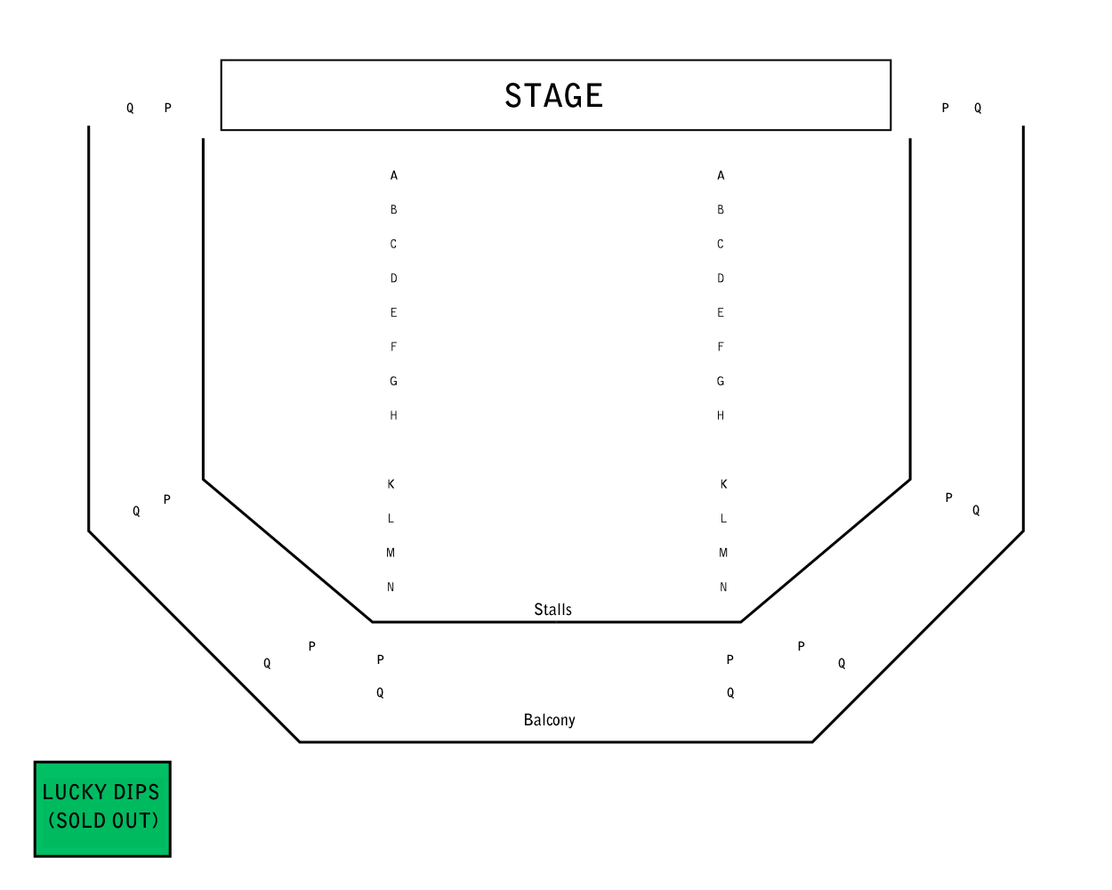

***The Little Foxes***

This show will take place in our main auditorium, which is the larger of our three performance spaces.

For this performance, the space will be in an “end on” arrangement, meaning there will be seats on one side of the auditorium facing the stage.

Access to the main auditorium is via the upstairs doors (rows K - Q) and downstairs (rows A – J) via the main doors. Rows S & T are in the gallery also accessible via the upstairs doors. Our ushers are on hand to help you, they wear red t-shirts and jumpers with our logo.

Please arrive at the Young Vic with your ticket ready on your phone. You could also print your ticket in advance of your visit, or you can collect your ticket from our Box Office.

**Facilities:**

There are toilets located on the ground and first floor at the Young Vic, via The Cut Bar. We have gender-neutral and accessible/baby changing toilets. Sanitary bins are available in all.

**Building Accessibility:**

All indoor venues are accessible with lifts & ramps and toilet provided.

**Assistance Dogs:**

Assistance dogs are always welcome at the Young Vic, if you are planning a visit, please let us know in advance which performance you will be attending by calling our Box Office on **020 7922 2922** or e-mailing [boxoffice@youngvic.org](mailto:%20boxoffice@youngvic.org) and we will be happy to look after your dog during the show.

**Access for all:**

For full information about our access measures, please visit our Access For All page, on our website here: [www.youngvic.org/visit-us/access-for-all](http://www.youngvic.org/visit-us/access-for-all)

**Warning timings:**

Act 1: 34 minutes in – Slap

Act 2: 20 minutes in – Onstage death / ableism

**Show Synopsis:**

**Potentially upsetting themes**

*The Little Foxes* is set in Alabama in the year 1900. The whole play takes place in the family home of Regina Giddens (**Anne-Marie Duff**) and Horace Giddens (**John Light**). The play begins with Cal (**Freddie MacBruce)** and Addie (**Andrea Davy)**, servants to the Giddens family. They are in the parlour, discussing the business dinner they are hosting for Regina’s family. Birdie Hubbard (**Anna Madeley**), Regina’s sister-in-law, enters, excited about showing the visiting Mr. Marshall her music album. Her husband Oscar Hubbard (**Steffan Rhodri**) enters and tells Birdie off for leaving the dinner table, speaking to her harshly and telling her that she is boring Mr. Marshall with her talking. Leo (**Stanley Morgan**), who is Birdie and Oscar’s son, enters. He is followed by the rest of the party: Regina, her daughter Alexandra (**Eleanor Worthington-Cox**), her brothers Oscar and Benjamin/Ben (**Mark Bonnar**), and the visiting William Marshall. Mr. Marshall is planning to enter a business venture with Regina’s husband Horace and her brothers, involving him building cotton mills in the south with their invested money. They toast to a successful business partnership. Leo and Alexandra leave with Mr. Marshall to drive him to the station.

After Mr. Marshall departs, Regina and her brothers celebrate and discuss what they want to do with the millions of dollars they will soon make. We learn that Regina wants to go to Chicago and become a fashionable society lady. Birdie tries to discuss her dreams to recreate the parties of her youth hosted by her kind mother and her desire for Oscar to stop hunting, but she is repeatedly talked over by the other three. Ben asks Regina when her husband Horace will return with his third of the money to invest. Horace is away visiting doctors in Baltimore due to his poor health and has not answered any of Ben’s letters on the topic. Regina reveals that she wants Horace to have 40% of the business rather than a third. Ben agrees, saying this extra will come out of Oscar’s share, if Horace returns immediately with the money to invest. Oscar is reluctant about this, but Ben convinces him that this is the best way to keep the money in the family, especially if Alexandra and Leo marry. Regina says she will consider the marriage.

Leo and Alexandra return, and Regina tells Alexandra that she is going on a trip to bring her father home. Regina goes upstairs to pack Alexandra’s things, and Ben, Oscar and Leo leave. Left alone with Alexandra, Birdie warns her about the plans being made for her to marry Leo, insisting she will not allow it. Oscar returns to get Birdie and overhears this. **Alexandra goes upstairs to pack, and as she leaves, Oscar slaps Birdie across the face.** Hearing Birdie cry out, Alexandra runs back downstairs, but Birdie reassures her that everything is fine, and everyone exits the stage. There is a brief pause here for a set change.

The next scene begins in the same parlour a week later. Oscar enters and is greeted by Addie. He is concerned as Alexandra and Horrace have been delayed in their return from Baltimore and no one has heard from them. Leo enters, and his father tells him off for leaving work, telling him he needs to settle down if he is to marry Alexandra. Leo and Oscar discuss what will happen if Horace refuses to invest. Leo reveals that he looked in Horace’s security deposit box at the bank, where he keeps 88 thousand dollars' worth of Union Pacific bonds. As Horace only checks on the bonds every 6 months, Oscar schemes about whether they could borrow the bonds without Horace noticing.

Ben enters, worried about the continued absence of Horace and Alexandra. Regina comes downstairs and tells her brothers and nephew not to worry. The four go into the dining room to have breakfast.

Horace and Alexandra arrive, and Addie runs into the parlour to meet them. Alexandra explains that her father found the journey very difficult, and they were delayed as he had to stop on the way to rest. Alexandra goes upstairs to change, first explaining to Addie the different medicines Horace needs to take for his heart. Left alone, Horace asks why Alexandra was sent to bring him home. Addie tells Horace of the business plan being schemed by Regina and her brothers, as well as the plan for Alexandra’s marriage to Leo. Oscar, Horace, Ben and Leo enter from the dining room and greet Horace with lies about how well he is looking. Birdie bursts through the door still in her dressing gown and greets Horace with real warmth. Oscar scolds her for arriving in her dressing gown, and she departs. Oscar, Leo and Ben go back into the dining room to finish their breakfasts, leaving Regina and Horace in the parlour.

Horace confronts Regina about what he’s heard about Leo and Alexandra’s marriage, insisting it will not happen as long as he lives. He then tells Regina that this may not be long, as he is very ill. Regina pointedly asks Horace if the doctors think his heart trouble is caused by his affairs with other women, and the two argue. Regina calls Oscar, Ben and Leo back in, insisting they must sort the business deal immediately, despite Horace’s protests that he is too ill. Regina explains the whole situation, but to everyone’s shock, Horace states that he will not invest his money, still angry that Regina was even considering marrying Alexandra to Leo. Ben tries to calm the situation, saying they can talk about it later when Horace has rested, but Regina is furious, insisting Horace explain his reasoning now. Horace retires upstairs, and Regina follows him. Left alone, Oscar and Leo reveal to Ben their plans to steal Horace’s bonds and invest his money without his consent to make them a profit. Ben agrees, and Leo and Oscar leave with plans to steal the bonds and go to Chicago to confirm the deal with Mr. Marshall.

Alexandra comes running downstairs upset and begs her Uncle Leo to persuade Regina to let her father rest, as she is worried about his health. Regina comes downstairs, having been unable to convince Horace to change his mind but reassuring Ben she will. Ben tells her it’s too late, they have found another investor and Oscar is on his way to Chicago to bring the money to Mr. Marshall. Ben leaves despite Regina’s protests. Horace appears on the stairs, and when Regina angrily asks him why he’s denied her the money after his death, he reveals he refuses to participate in her and her brother’s destruction and exploitation of the town, as he wants to die with a clean conscience. Regina is furious and tells Horace she can’t wait for him to die, leaving Alexandra very distressed.

There is now a 20-minute interval.

The second Act opens with Horace, Alexandra and Birdie in the parlour. Horace has his safe deposit box on the table. Birdie and Alexandra are playing the piano, and Birdie is reminiscing about playing music with Horace in the days before her marriage. Horace asks Birdie if Oscar has returned from Chicago, and she confirms he has and seems in good spirits. Addie comes in with cakes and wine, and Alexandra remarks how lovely it would be if it could always be just the four of them. **Birdie continues talking of Horace’s kindness to her when they first met, and hints that once he prevented Oscar from abusing her.**

Cal arrives, having been called for by Horace. Horace tells Cal to go to the bank and tell Mr. Manders the bank manager and his employees, including Leo, that his safe deposit box was delivered to him successfully. Cal is confused by this as Manders delivered the box himself but agrees and goes. Birdie, getting more and more drunk, admits that she regrets marrying Oscar and her dislike for her own son. She reveals the Hubbard's manipulate her into a marriage to obtain her aristocratic family’s money and assets. **She admits she has a drinking problem and is depressed.** When Alexandra tries to comfort her, Birdie warns Alexandra that the same fate awaits her. Alexandra leaves to walk Birdie home, leaving Addie and Horace onstage. Horace explains to Addie he is happy Birdie told Alexandra this warning, as he is planning to persuade her to escape her mother and the Hubbard family. He explains to Addie that he wants her to take Alexandra away and that he is re-writing his will to leave money to them both.

Cal returns and tells Horace that Leo was upset to hear Horace had the safe deposit box, just as Horace planned. Regina returns, and Horace explains the situation to her. He tells her he plans to say that he lent Leo the bonds so she cannot make any money from her brothers’ investment. He explains he plans to leave her the 88 thousand in Pacific Union Bonds and leave the rest of his money to Alexandra. The two argue about the failure of their marriage, and Regina explains she only married Horace because she knew it was her only way to hope to be wealthy after her father left all the money to her two brothers when he dies. As she explains this, Horace’s health deteriorates. He tries to take his medicine which is on the table but drops the bottle and spills the medicine. He asks Regina to call for Addie to get his other medicine upstairs, but she does nothing. He tries to crawl up the stairs but collapses as he reaches the top. Regina then follows him and calls for Addie and Cal, pretending she just found Horace collapsed on the stairs. Alexandra arrives and encounters Addie leaving to fetch the doctor. Alexandra goes upstairs to her father and Addie leaves.

Oscar enters the house to find the parlour empty. Cal comes downstairs on his way to fetch supplies and explains to Leo what has happened on the way. Ben and Oscar enter, and Leo explains that Horace knows about the bonds. They wonder together whether Horace told Regina as they were fighting, deciding that they’ll say he lent Leo the bonds and hope to get away with it. Addie returns and sends Cal in a carriage for the doctor who is away from home. Regina then comes downstairs and confronts the three men, explaining that Horace told her everything. She explains that, if Horace dies, she wants 75% of the business in exchange for the bonds. Ben and Oscar insist that she has no proof to blackmail them into this. This conversation is interrupted by the appearance of Addie and Alexandra on the stairs, signifying that Horace is dead. Addie leaves the room, but Alexandra refuses to, even when her mother asks her to, coldly asking her in response what her father was doing on the staircase. Regina goes back to threatening Ben, Oscar and Leo with exposing the truth, which even if it does not result in their conviction for theft will lead to social ruin. They can see no option but to accept Regina’s request for 75%. Oscar and Leo leave humiliated. Ben congratulates Regina for a game well played, explaining that in this new century, the world belongs to people like the Hubbards, who seize what they want regardless of the damage it causes. He hints that he suspects she was responsible for her husband’s death, and that someday he may accuse her of it, before he also leaves.

Alexandra and Regina are left alone in the parlour. Regina tells Alexandra she plans for them to go to Chicago very soon, that a change will be good for them after this shock. Alexandra tells her mother she will not go with her. Regina tries to dismiss this, but Alexandra calmly explains she refuses to become like her mother and their brothers, that she understands the lesson her father tried to teach her before his death. Regina, intimidated by this sudden demonstration of strength from her daughter, tries to appeal to her emotionally, saying she doesn’t want them to be enemies. Alexandra simply responds, “Are you afraid, Mama?”. The play ends.

If you would like any further clarification or have any questions, please do get in touch with our Box Office team.   
  
Email: [**boxoffice@youngvic.org**](mailto:%20boxoffice@youngvic.org)  
Phone number: **020 7922 2922**   
  
See you soon!   
  
**Welcome Team**